**Jenkins Task-1**

**Task Description:**

Launch jenkins and explore creating projects and users.

**Launch Jenkins using AWS**

https://www.jenkins.io/doc/tutorials/tutorial-for-installing-jenkins-on-AWS/  
  
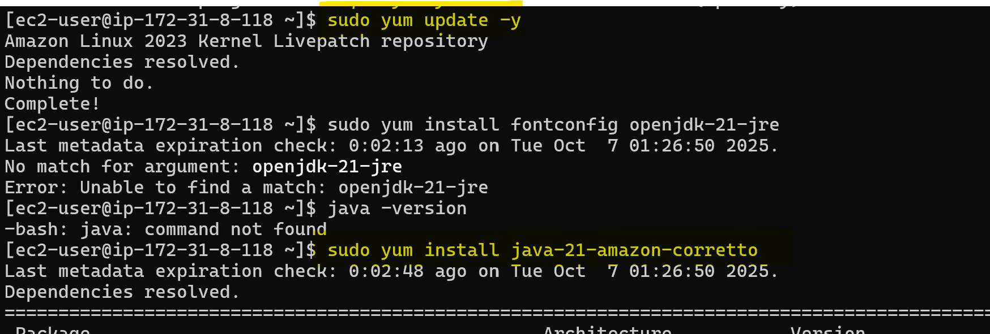

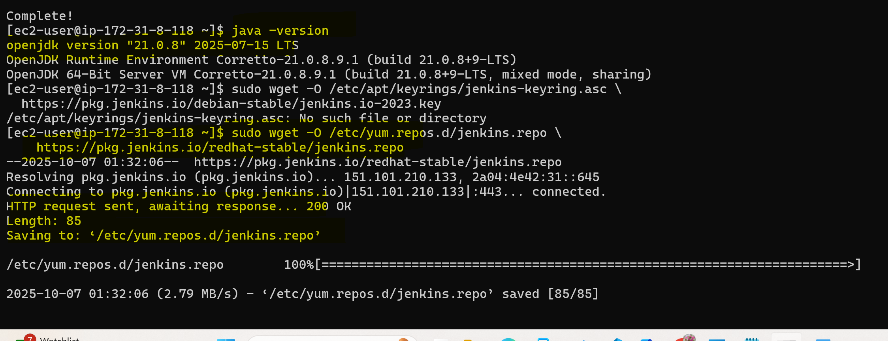

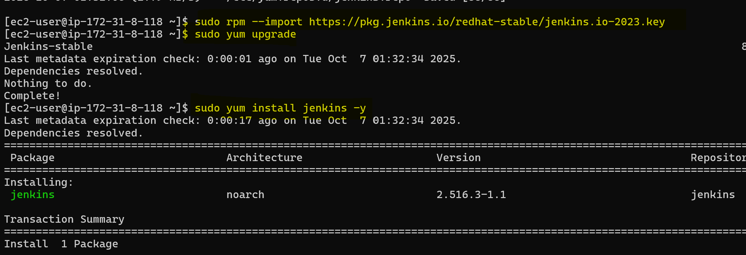

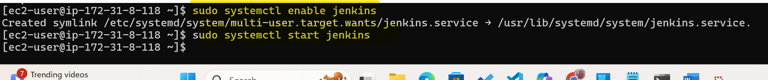

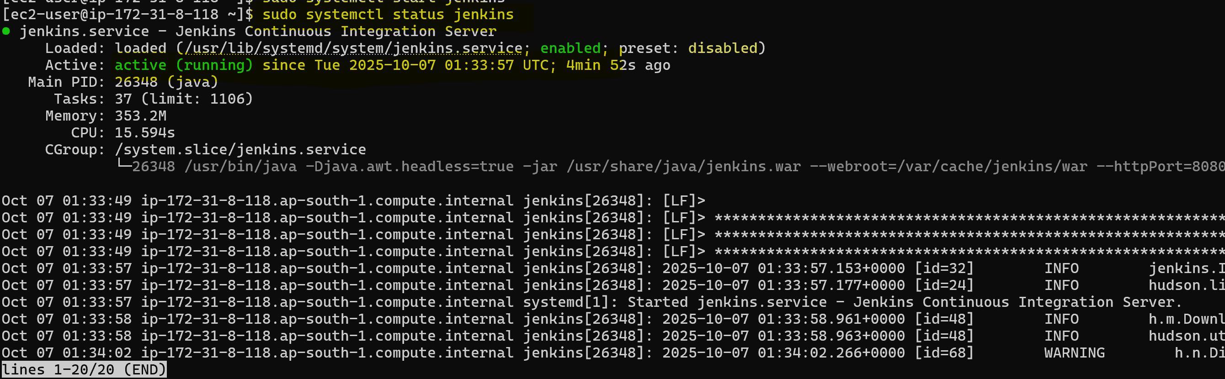

Allow 8080 port in SG  
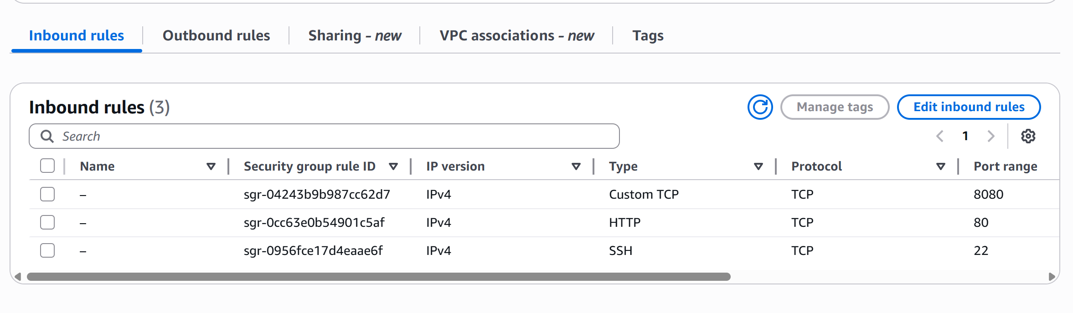

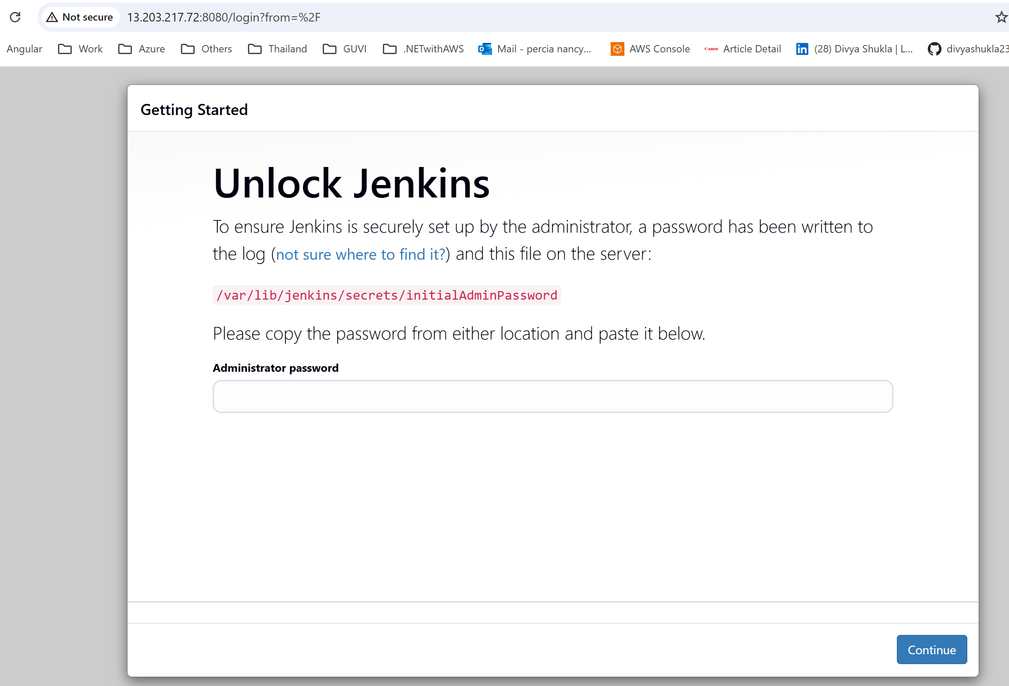

Get password



I got this error in **Built-In Node**

Disk space is below threshold of 1.00 GiB. Only 470.18 MiB out of 474.69 MiB left on /tmp.

Used below commands

Message means Jenkins is still seeing your /tmp directory as too small—even after all the cleanup and threshold adjustments. The root cause is that /tmp is mounted as a **tmpfs**, which uses RAM and is capped at around **475 MB**. So no matter how much disk space your EC2 instance has, Jenkins will keep flagging /tmp as low.

Final Fix: Remount /tmp to Use Disk Instead of RAM

Let’s bind /tmp to /var/tmp, which lives on your actual disk and has more space.

Step 1: Clean /tmp

**sudo rm -rf /tmp/\***

Step 2: Bind /var/tmp to /tmp

**sudo mount --bind /var/tmp /tmp**

Step 3: Restart Jenkins

**sudo systemctl restart jenkins**

**Create a Freestyle project**

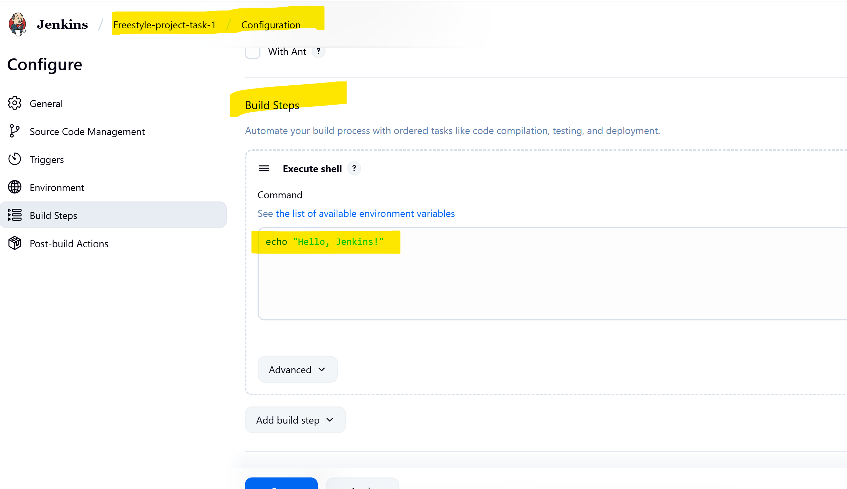

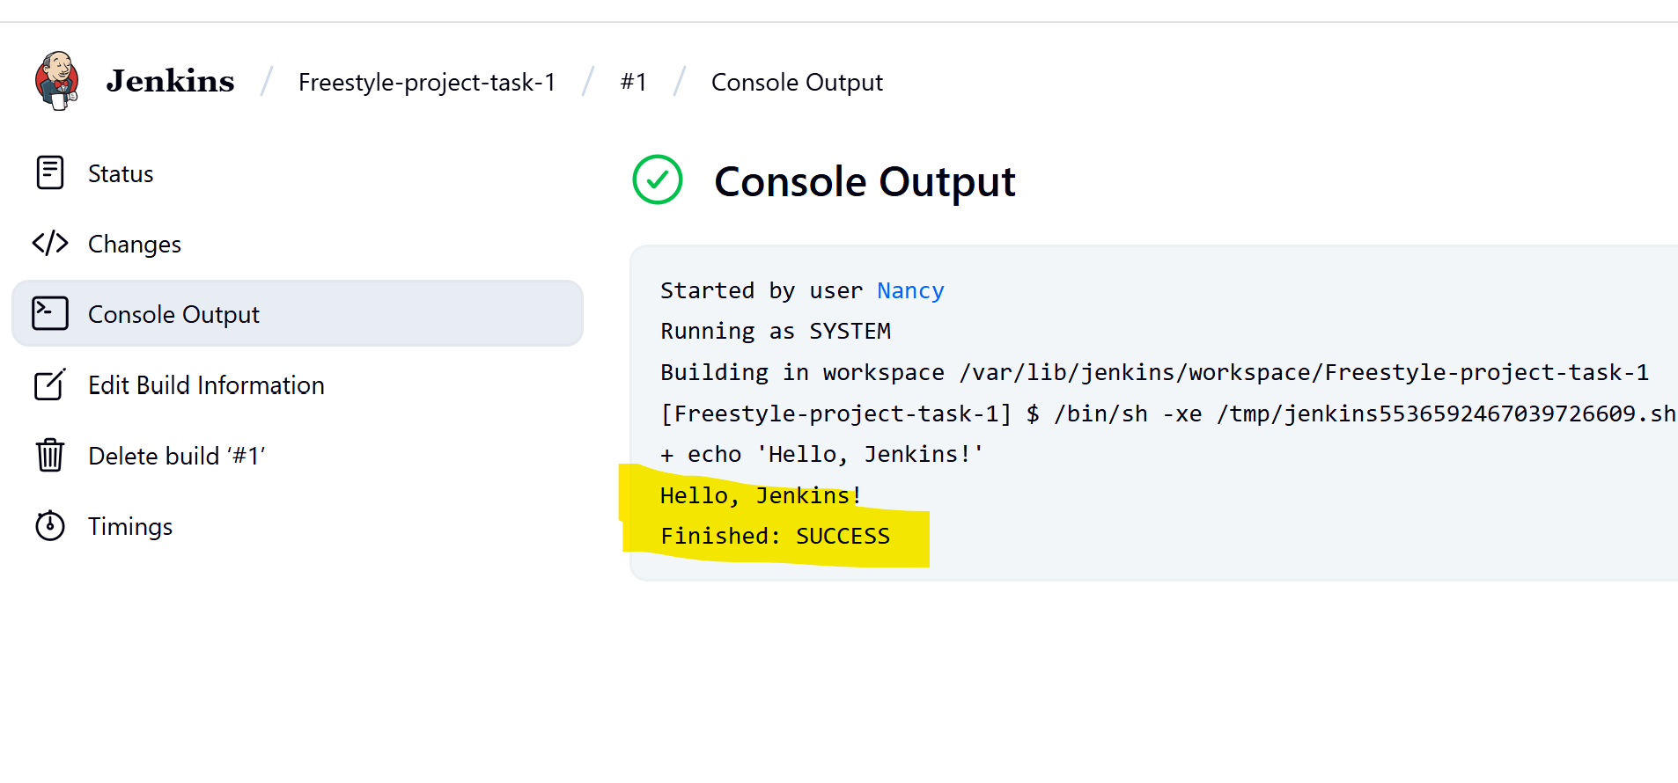

**Created another freestyle project by installing plugin ssh over publish**

Created new EC2 server and given EC2 public IP information in below section

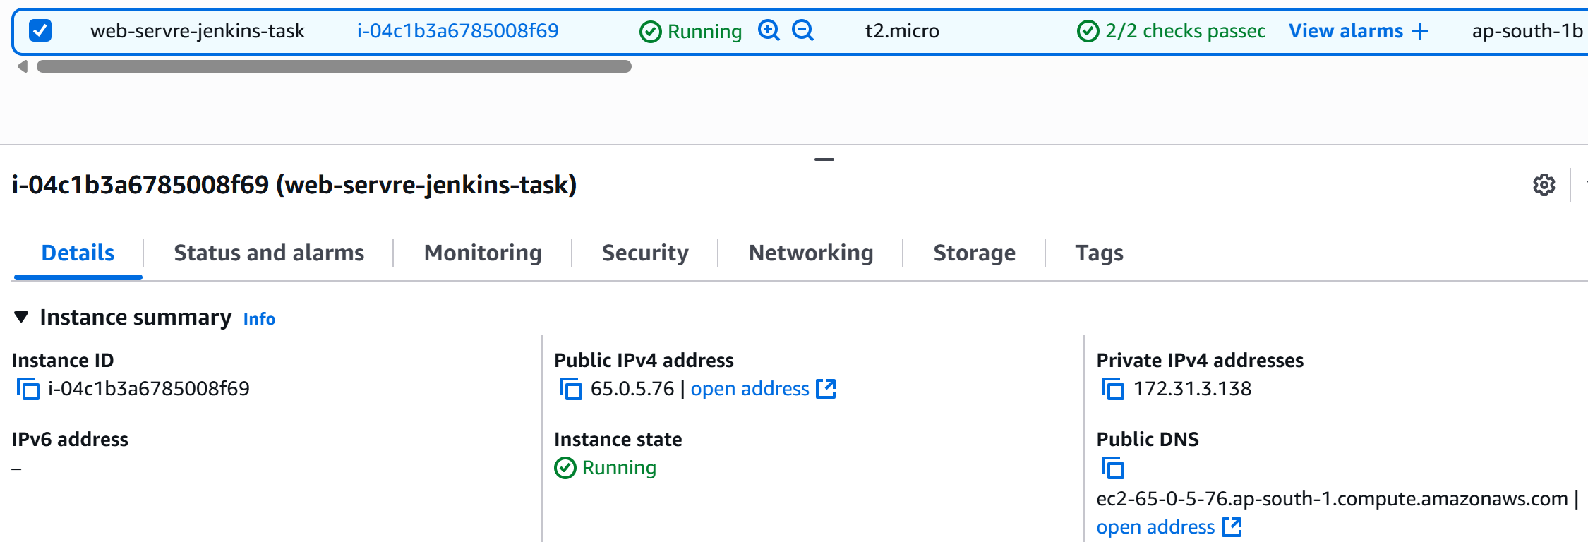

SSH Key Setup in Jenkins

Go to: Manage Jenkins → Configure System → Publish Over SSH  
  
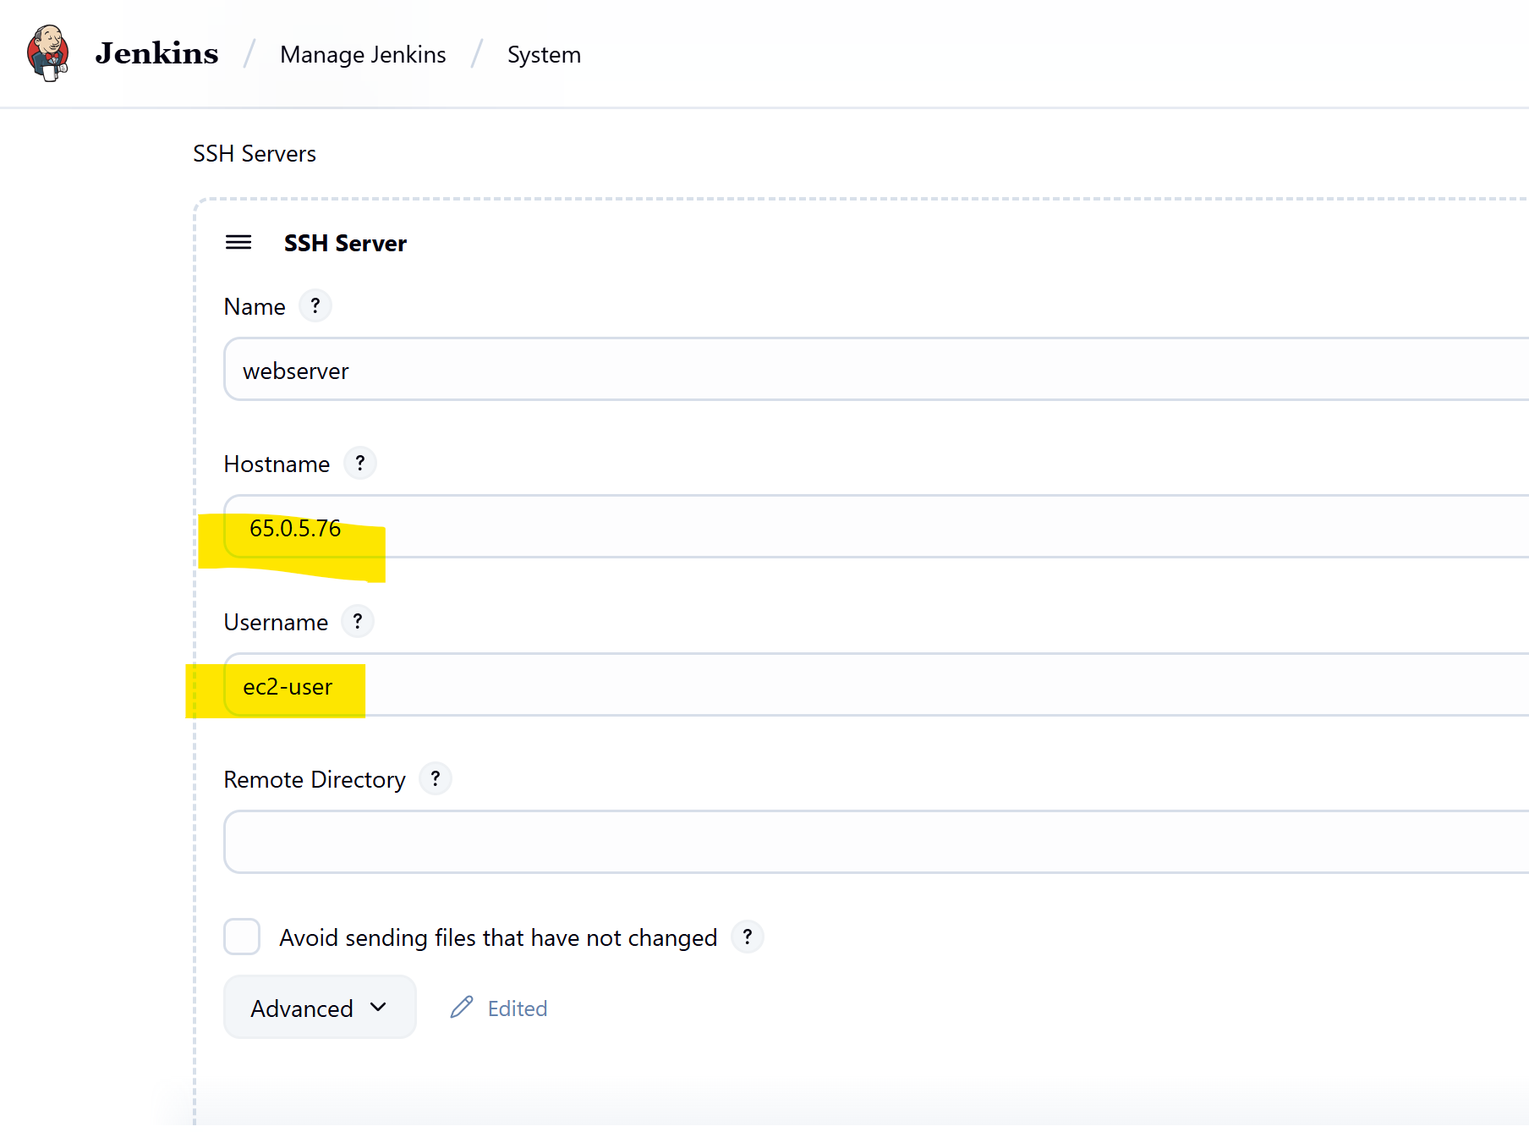

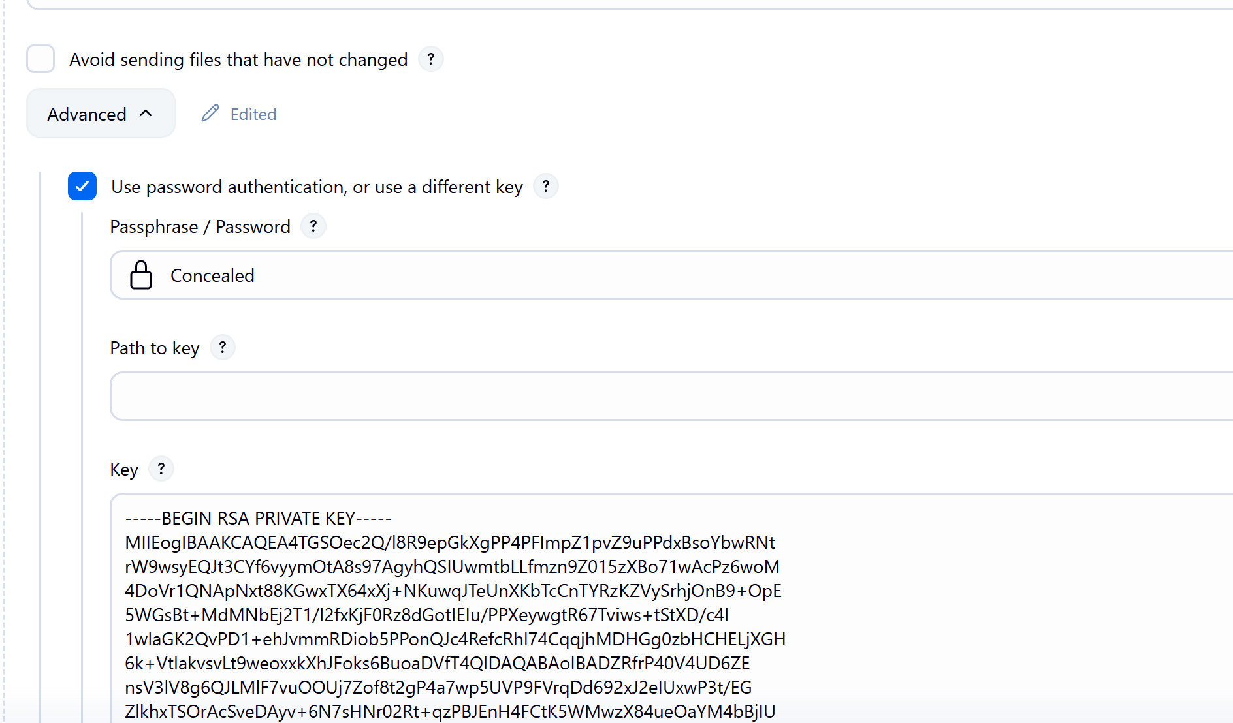

In new freestyle project select the configured SSH server  
  
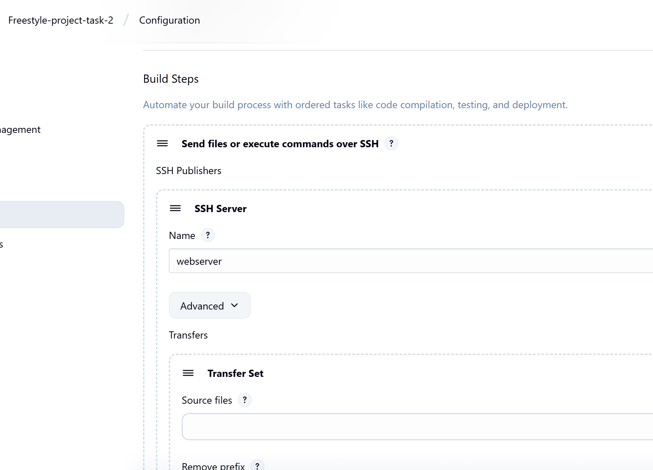

Install Apache , GIT , clone the git repo and replace the default html page

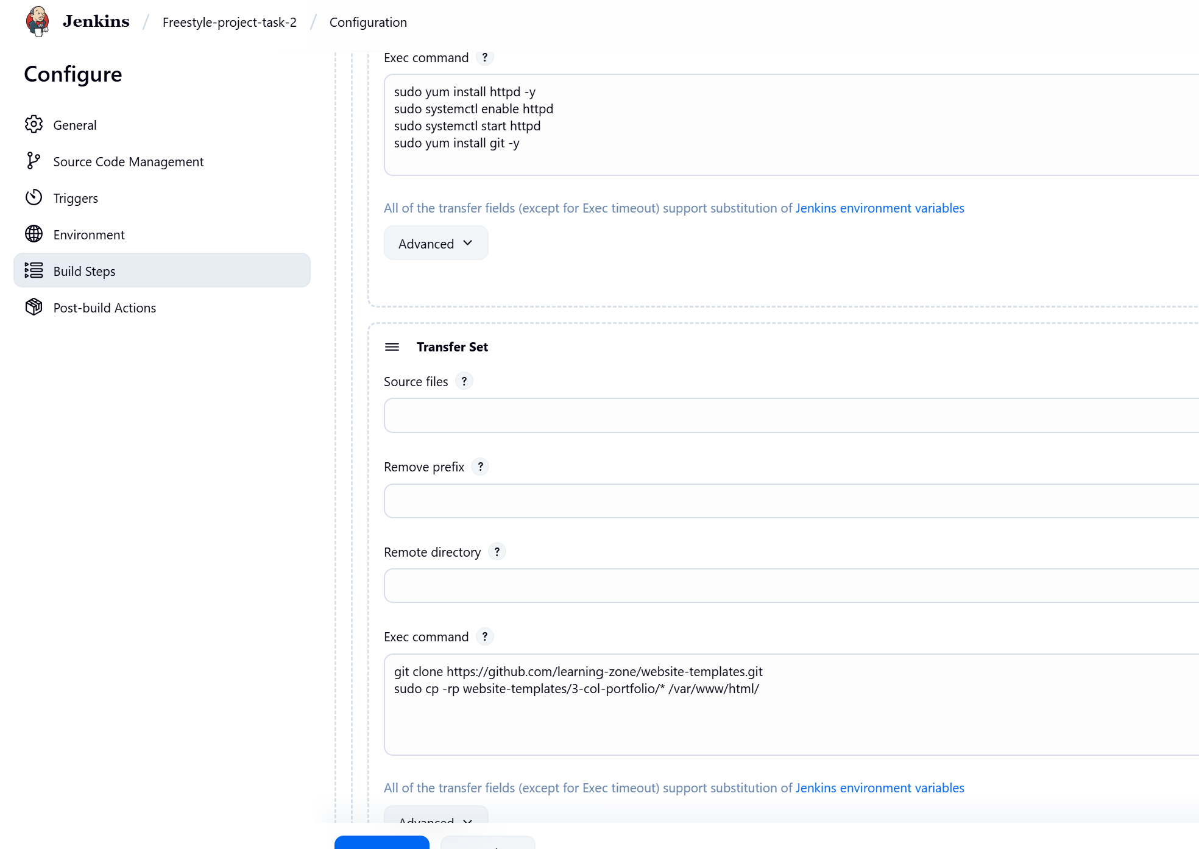

Browse the public url

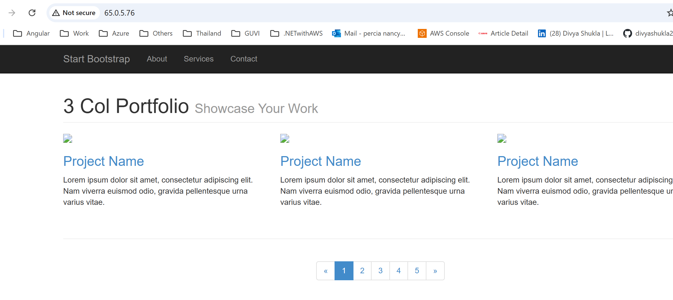

Pipeline project

Install below plugins

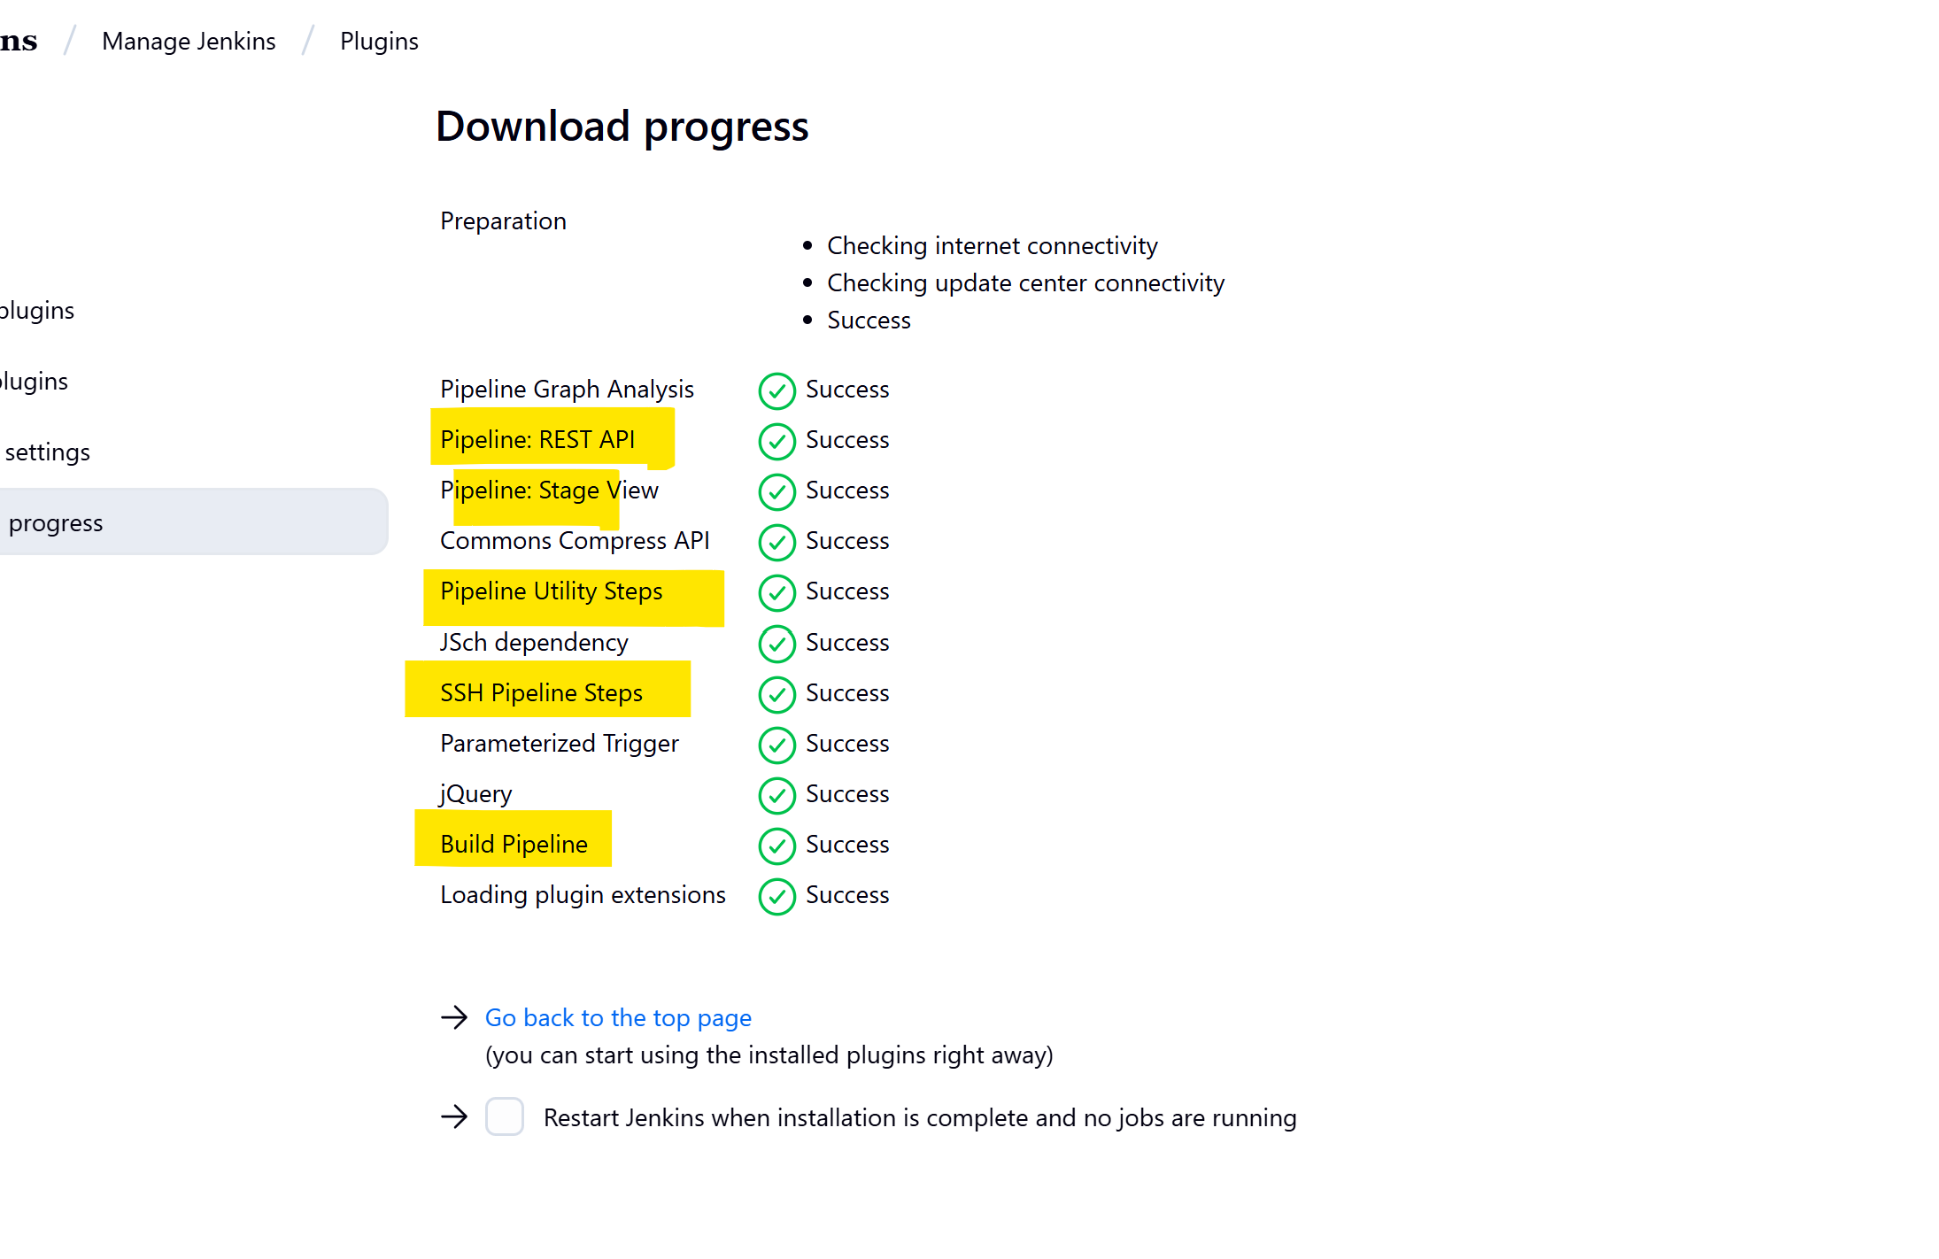

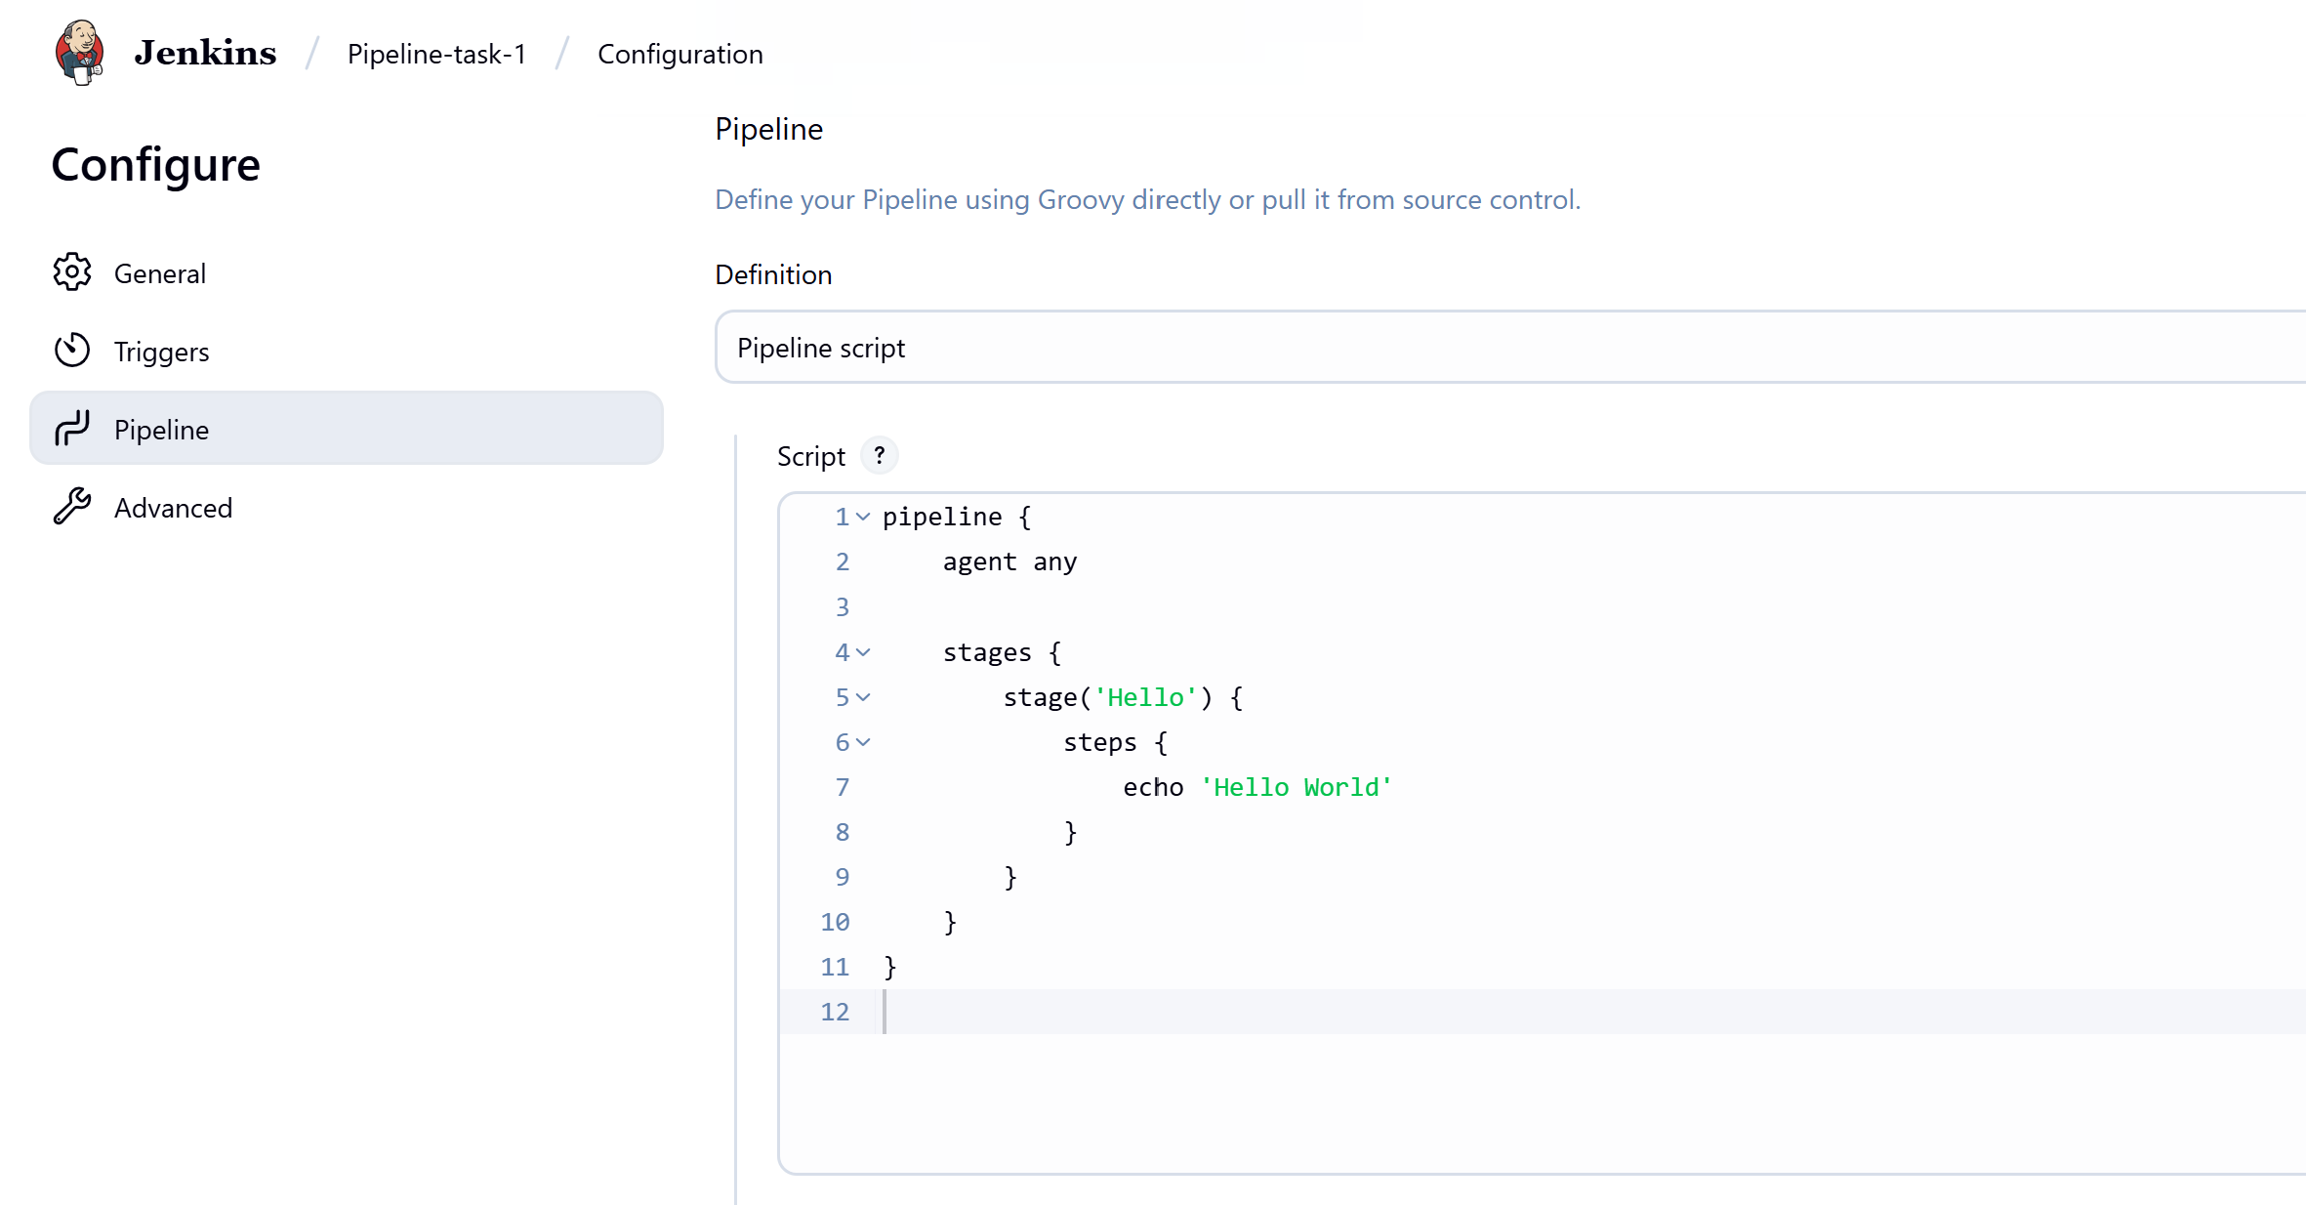

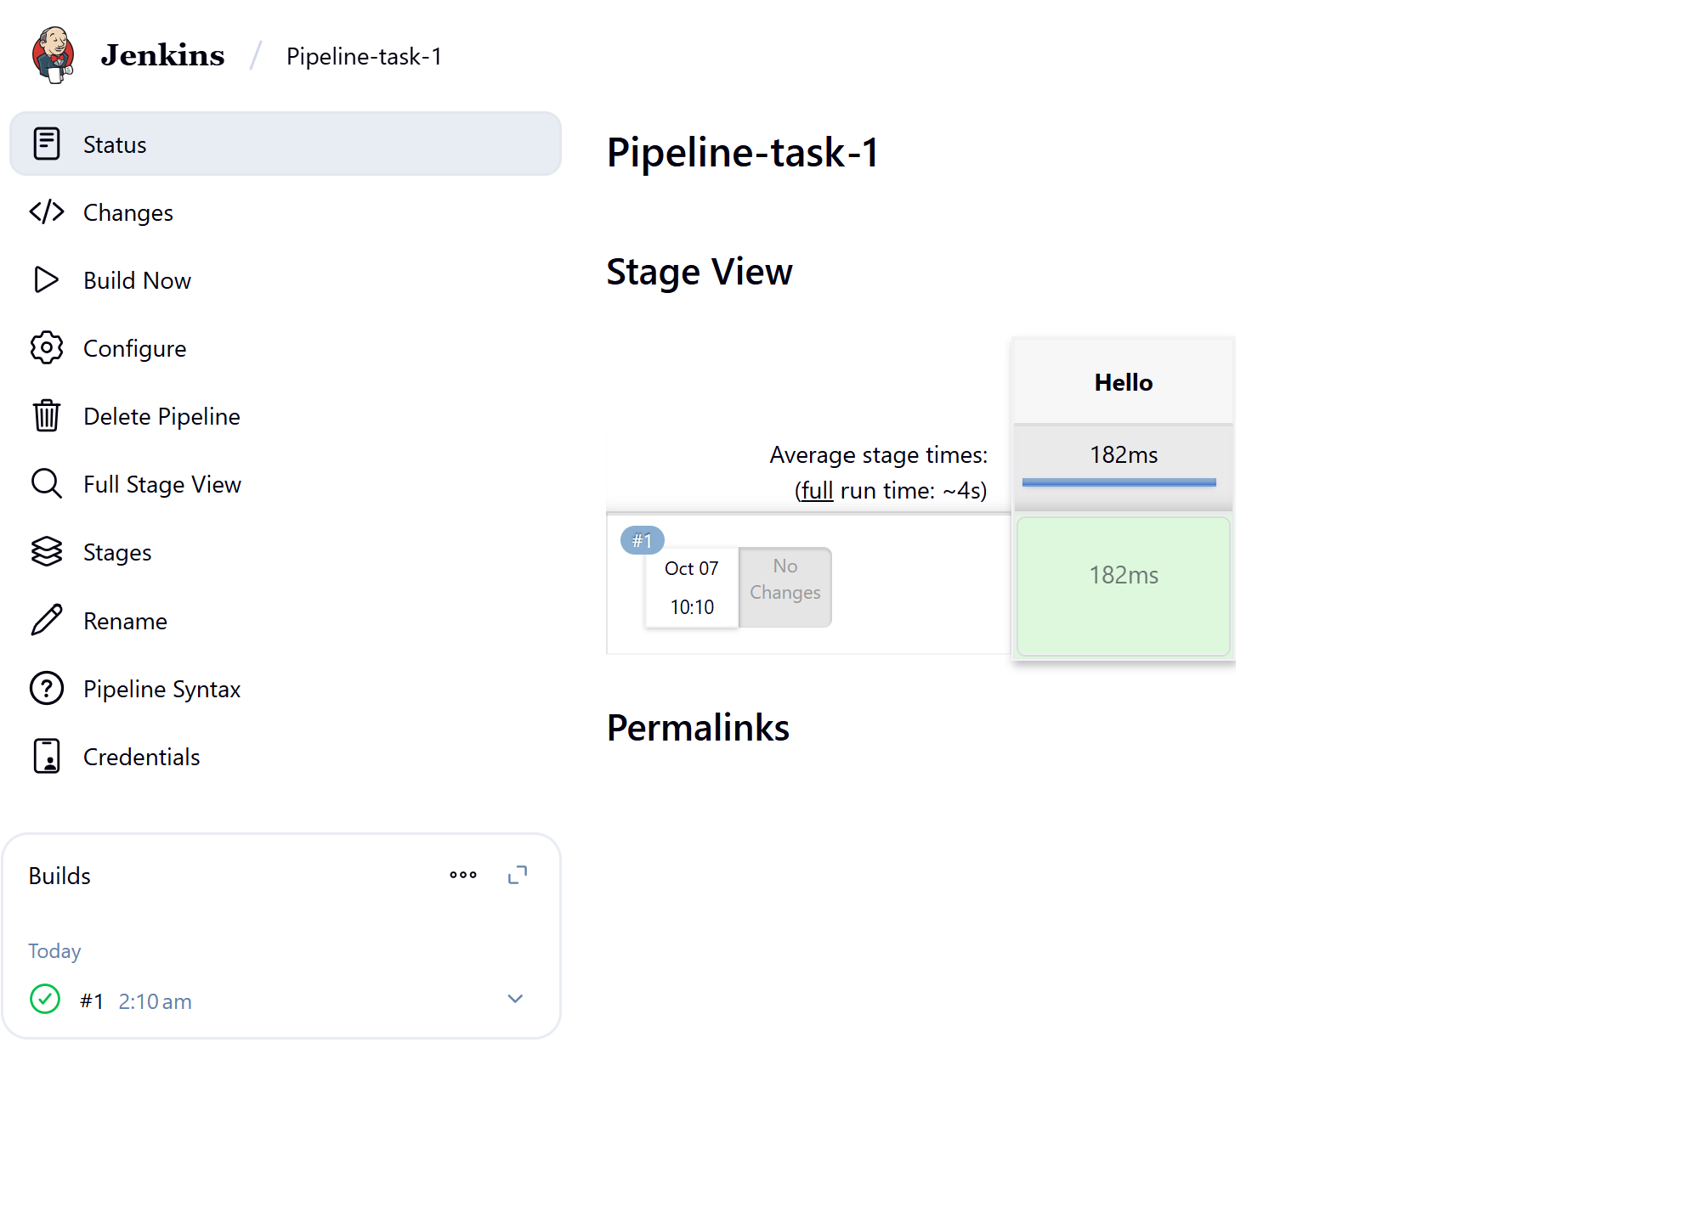

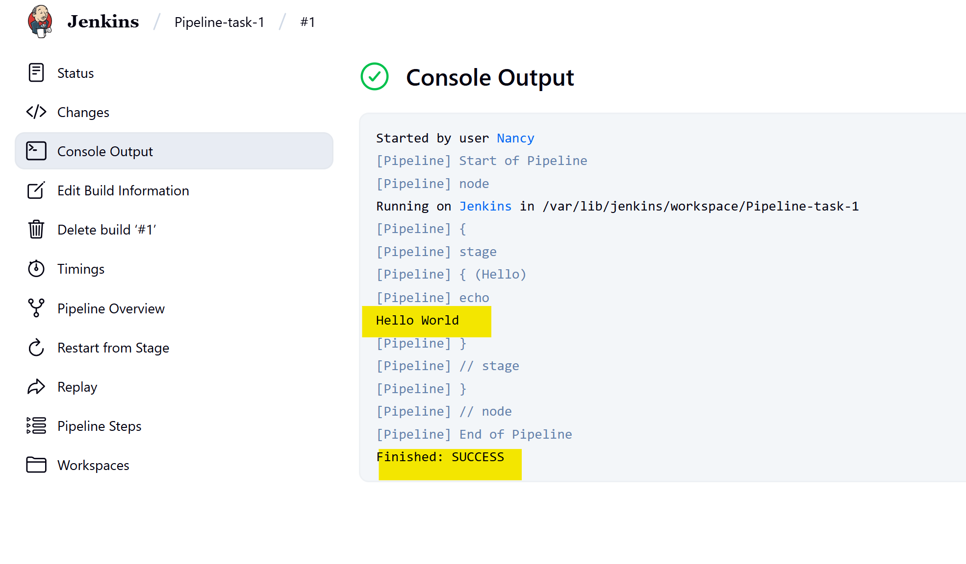

Created new user

